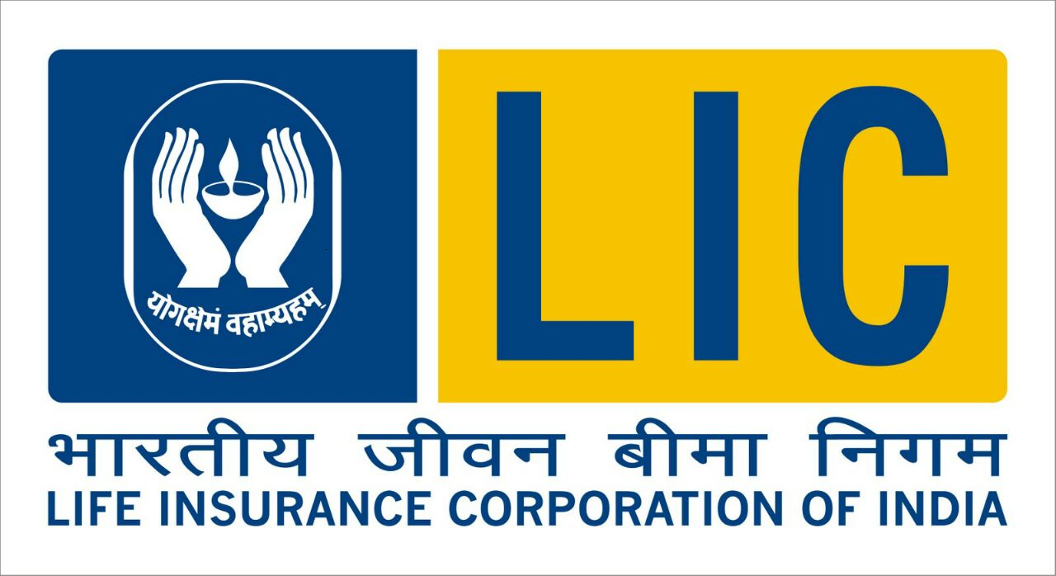
LIC AGENCY Sponsorship Form
Applicant's Photo*
-----------------------------
Applicant Name * Mr. /Ms. /Mrs. /Dr. __________________________________

OCCUPATION ____________________________________________________

Father/Husband Name * ____________________________________________

Father/Husbands Occupation______________________________________

PAN ____________________________
___________________+_
Aadhar Card * ____________________________

Basic Qualification Detail * Class X

Board Name * _____________________ROLL NO.___________________

MONTH & YEAR OF PASSNG___________________

HIGHER QUALIFACTION: _______________________

Date Of Birth (dd MMM yyyy) * ___________________

Sex * Male / Female ____________________________

Contact Information:

Current Address:
House Number * _______________________Street / Road * _______________________

Town / City * _______________________ State * _______________________

District * _______________________ PIN Code * _______________________

Phone No. _______________________ Mobile No. _______________________

E-mail ID _____________________________________________________________

Home District/State___________________________________

*Examination LANGUAGE ______________________

GIVE TWO REFERENCES (Name and Address)

1.__________________________________________________________________________________

2.__________________________________________________________________________________

Training Mode * Online / Offline _______________________

Training Institute Name * _____________________________

Accreditation Number * ______________________________

__________________________
SINGATURE OF APPLICANT

DOCS: PHOTOCOPIES OF X CERTIFICATE, PAN CARD, 3 PHOTOS, AADHAR CARD/ADD. PROOF
FEES: RS. 150/- CASH TO BE DEPOSITED IN LIC BRANCH. RS. 425 + GST (RS.502) DEP ONLINE

